IFB299

Application Design and Development

Reflective Journal

Tutor: Ben Saljooghi

Student: Chun-Ting Chen

Student Number: N8720347

**Week2-5**

From Week 2 to week 5, our team is working on the Release 1 and 2. We all bring up with some ideas to build our website and set it with the story points. After we finish our release plan section we start working on our sprint plan 1. So we all can following the step from the table and give the story point we actual spend time on the task.

**Release 1**

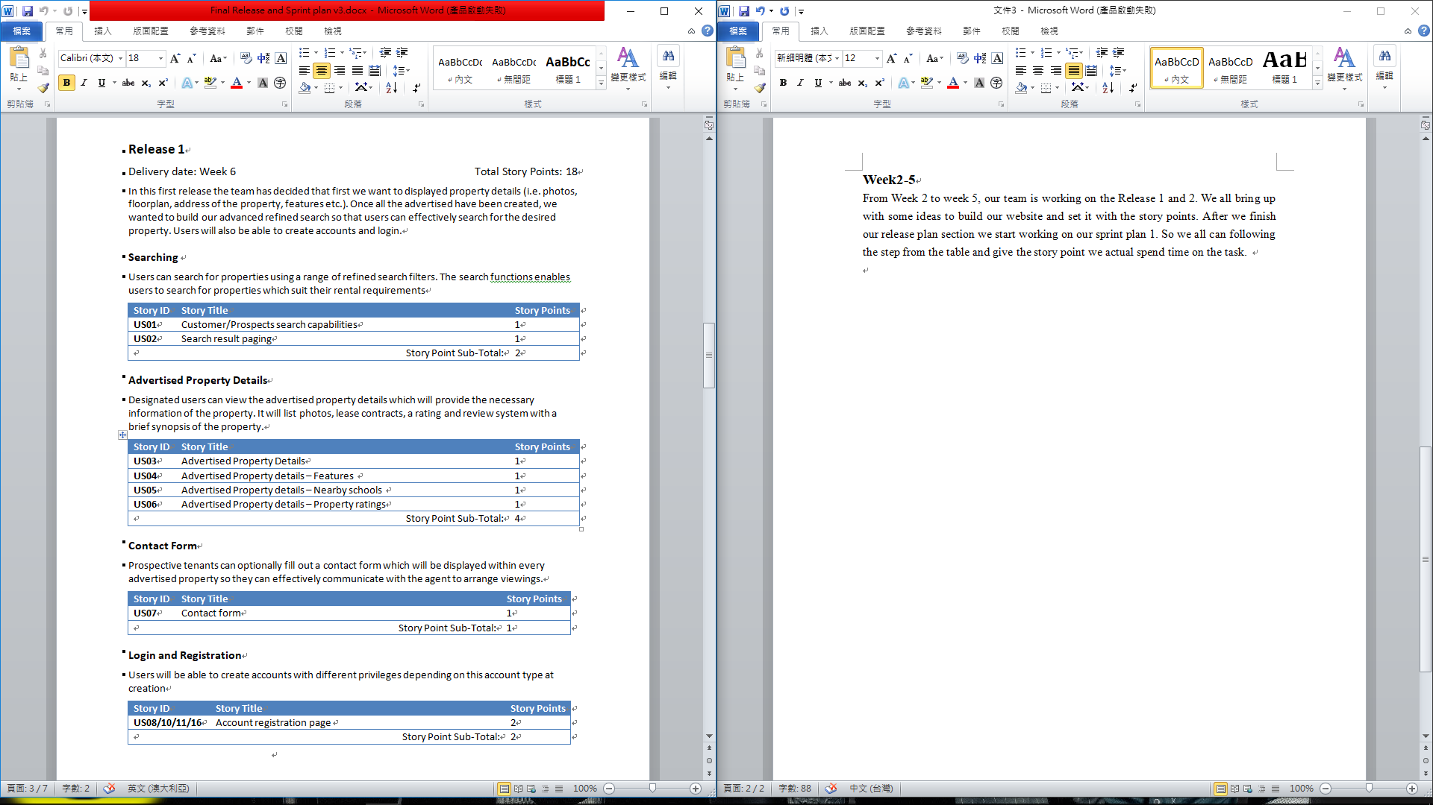

**Release 2**

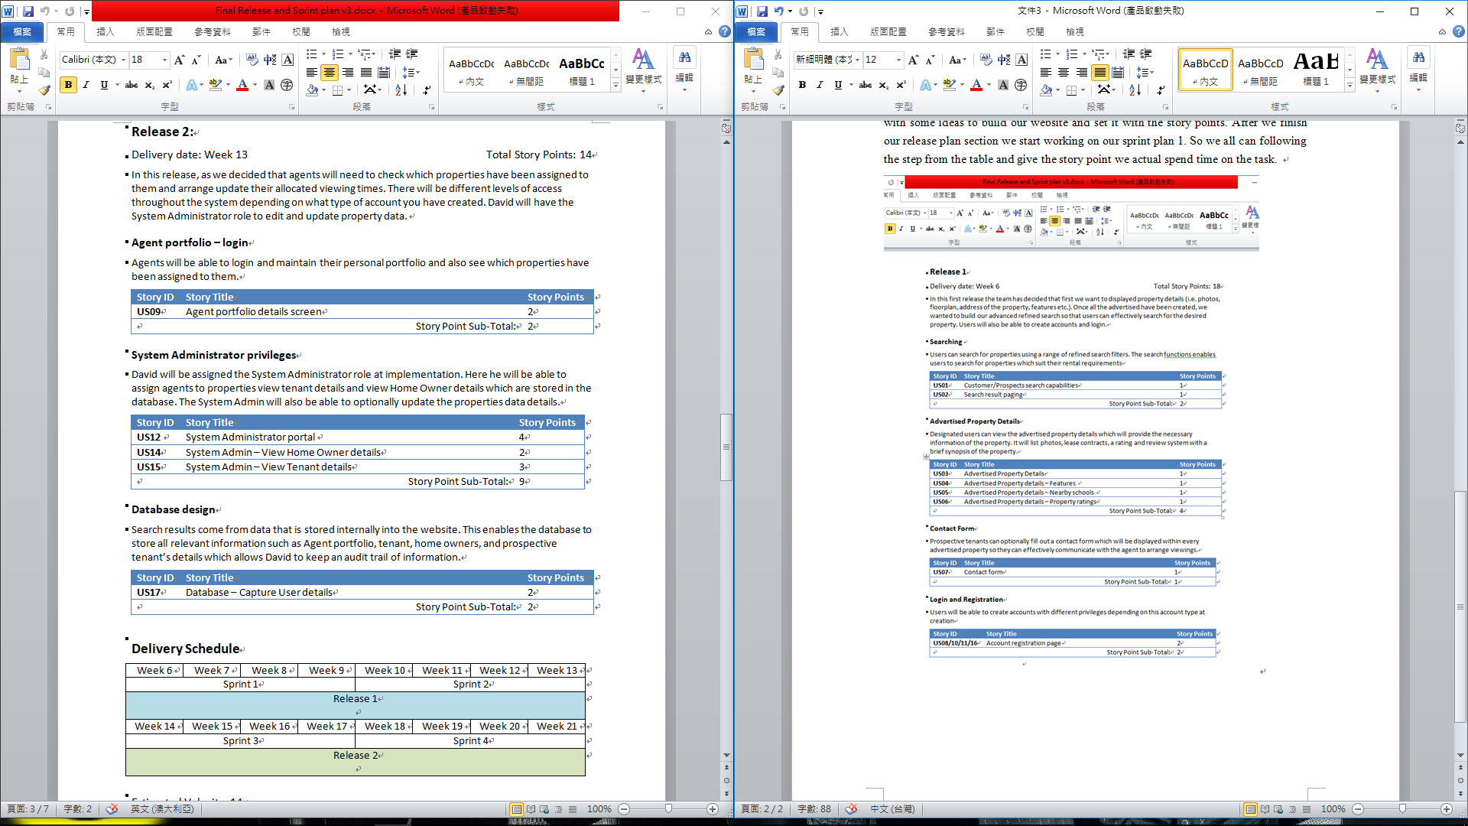

**Sprint Plan 1**

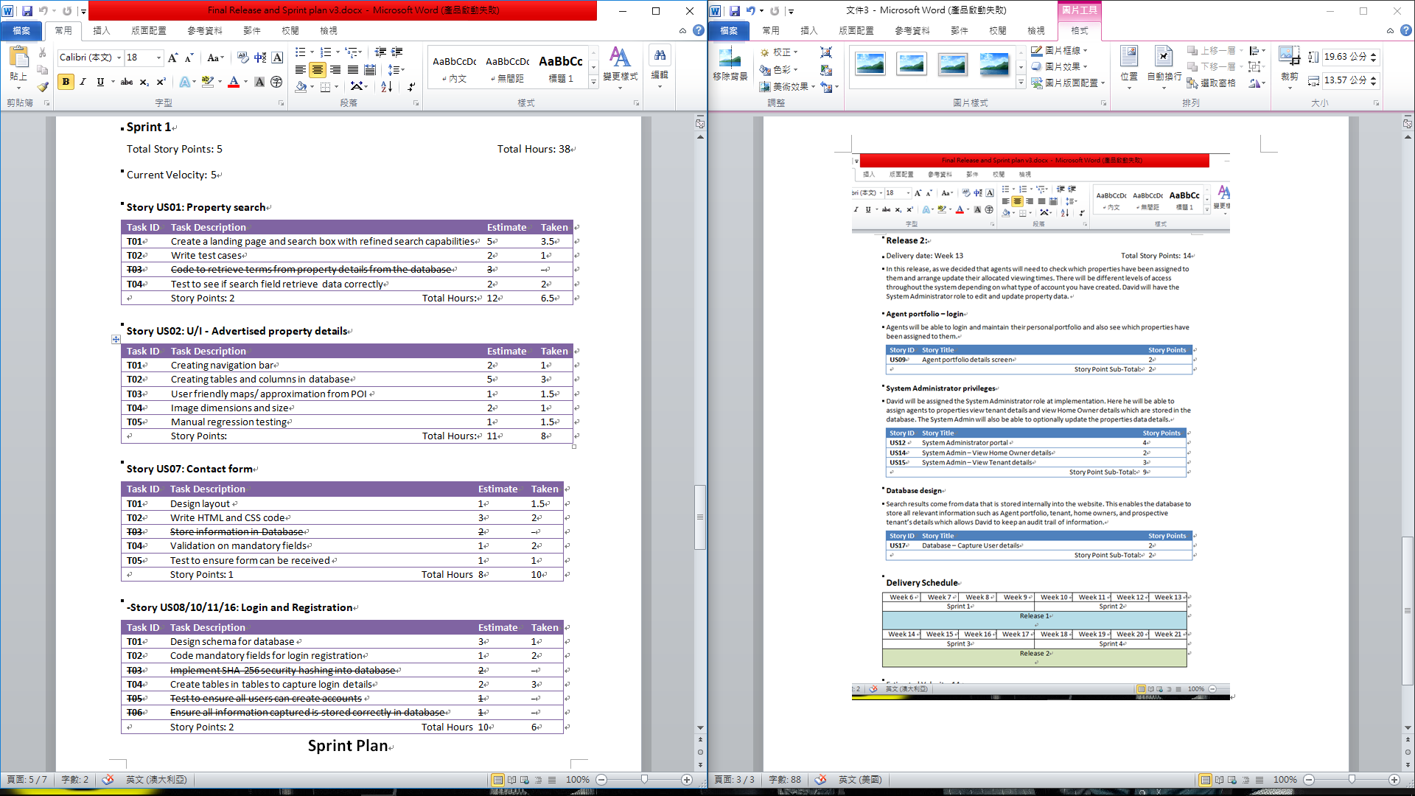

Then we had a coup of meeting that we contact each other by Facebook and some of our meeting was during our tutorial time to discuss our project and website.

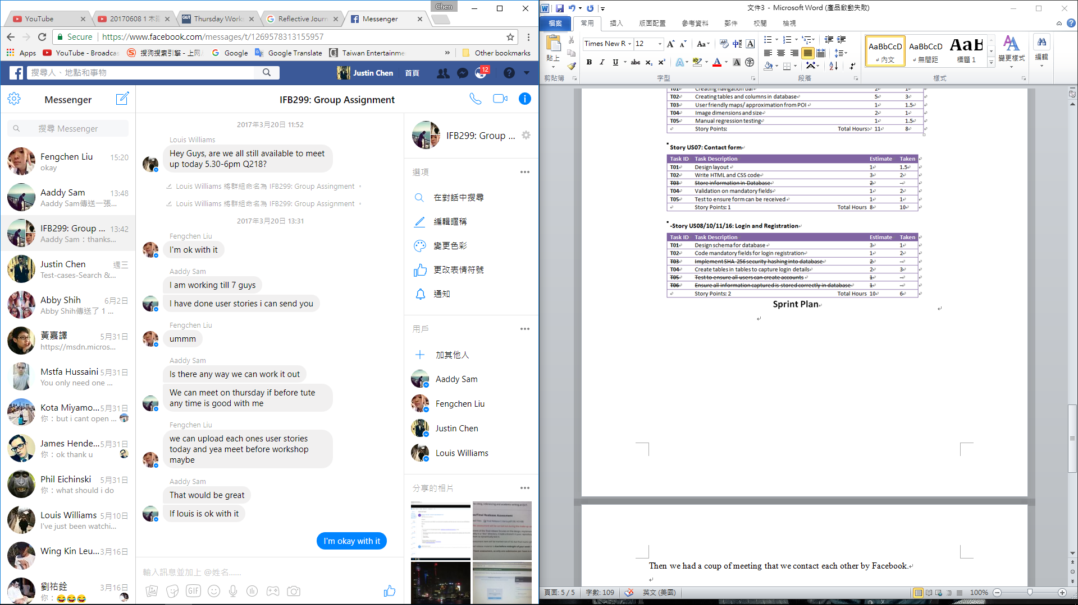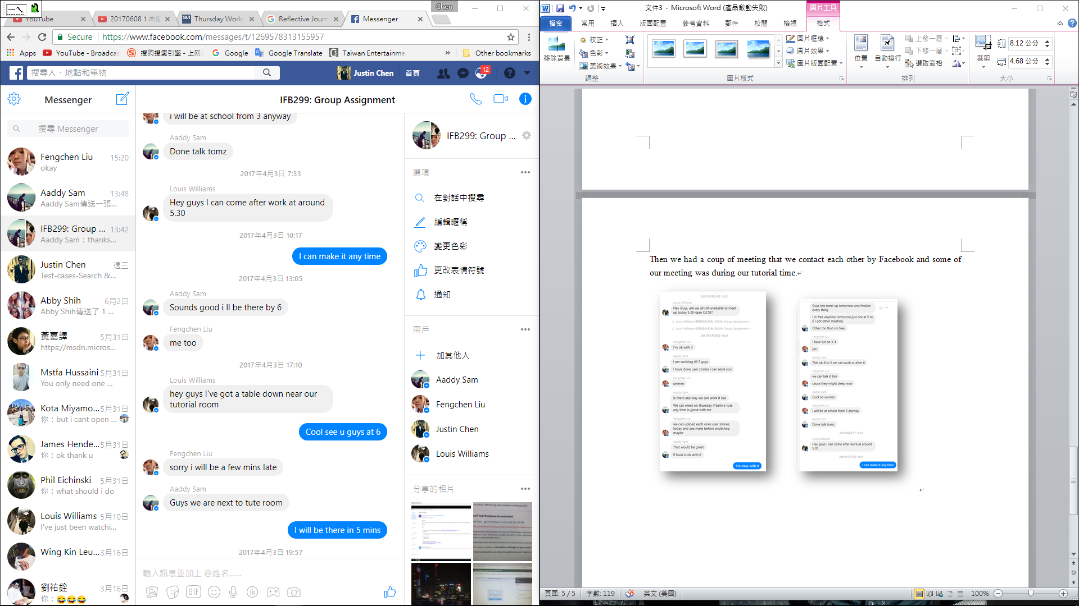

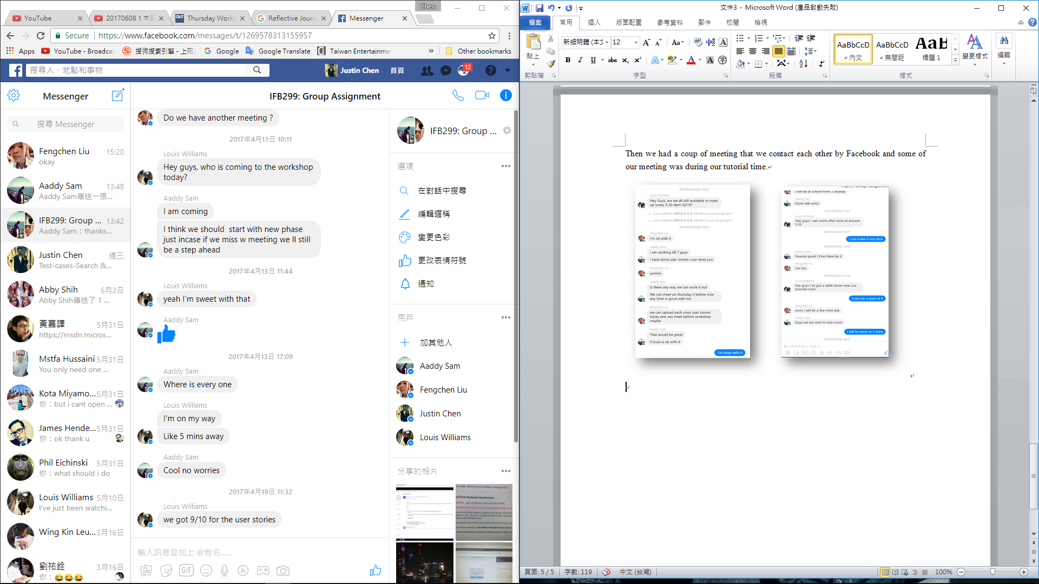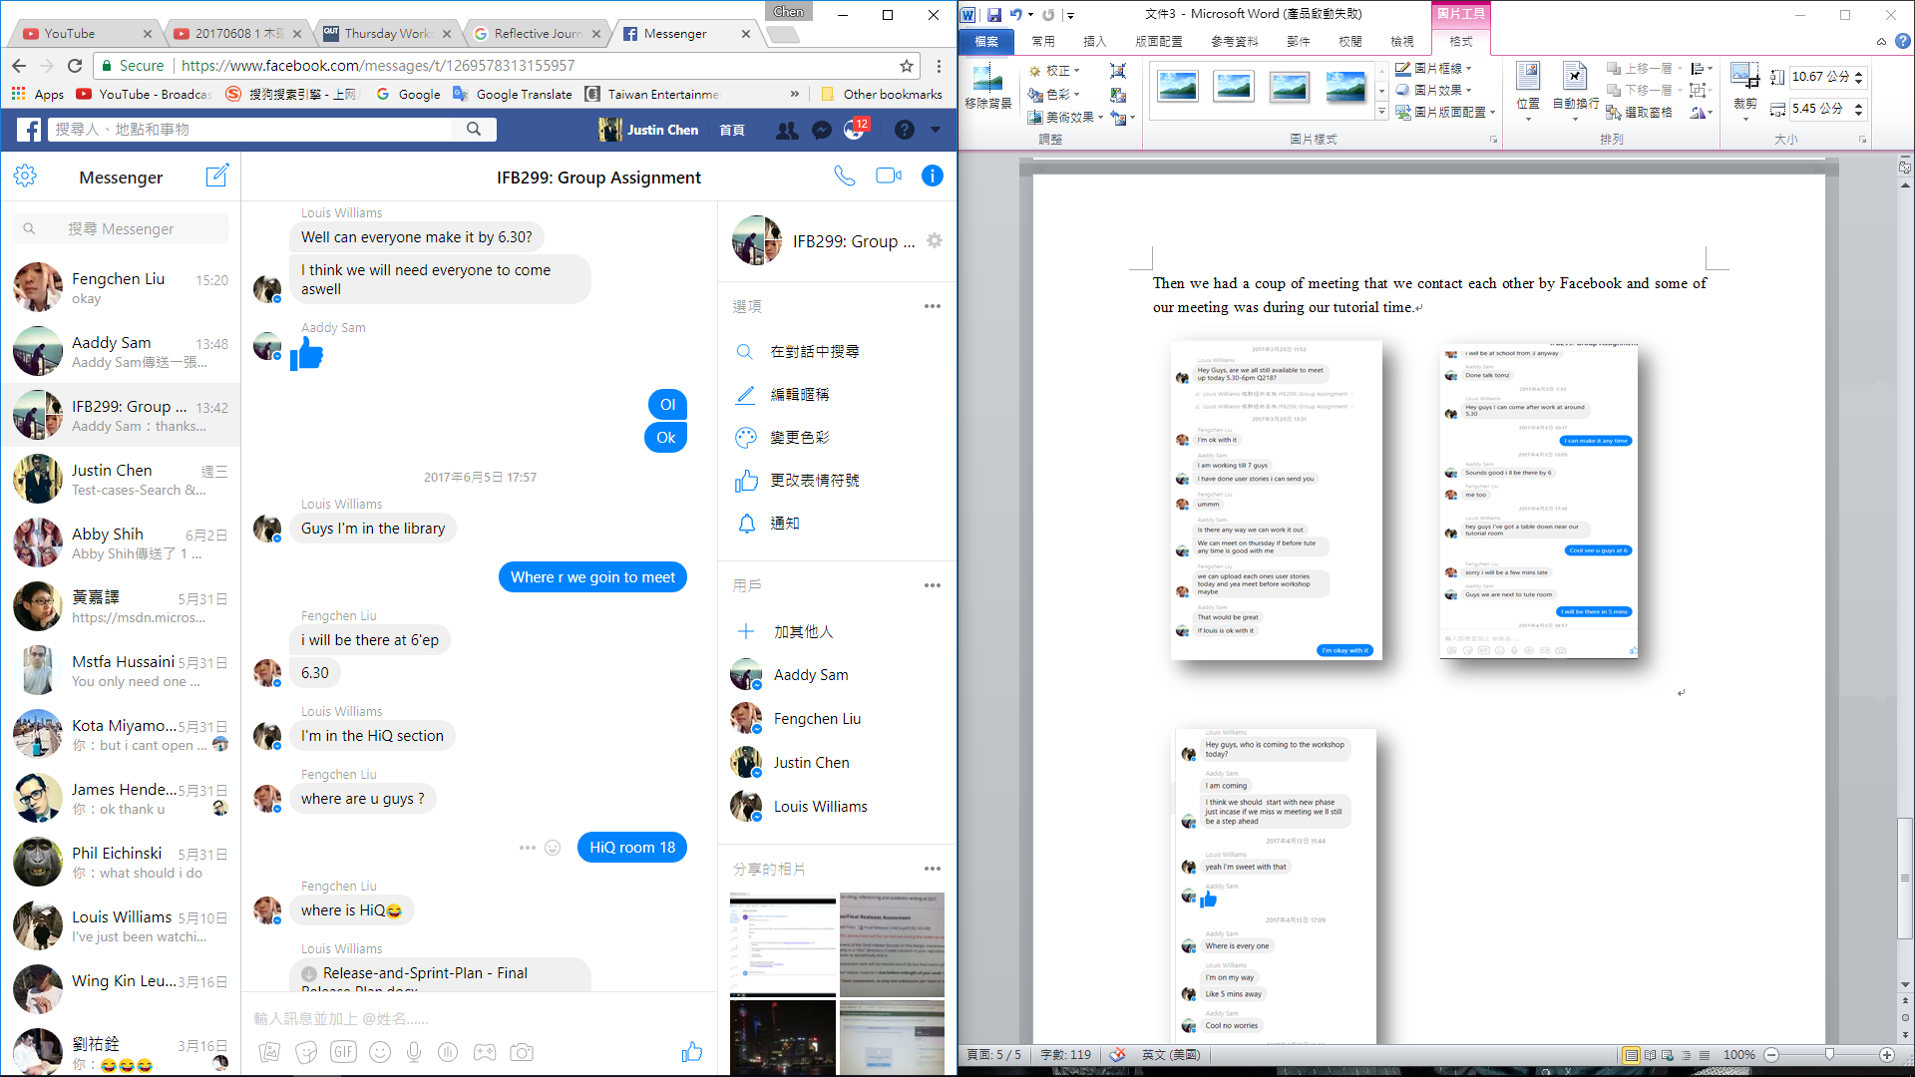

**Week6-12**

We star working on our individual work from our task. Me and Louis was working on the development code. So I start using my html code experience to write the website. At first two week it comes out with the demo web. So Louis can easily to put the form and database into the web.

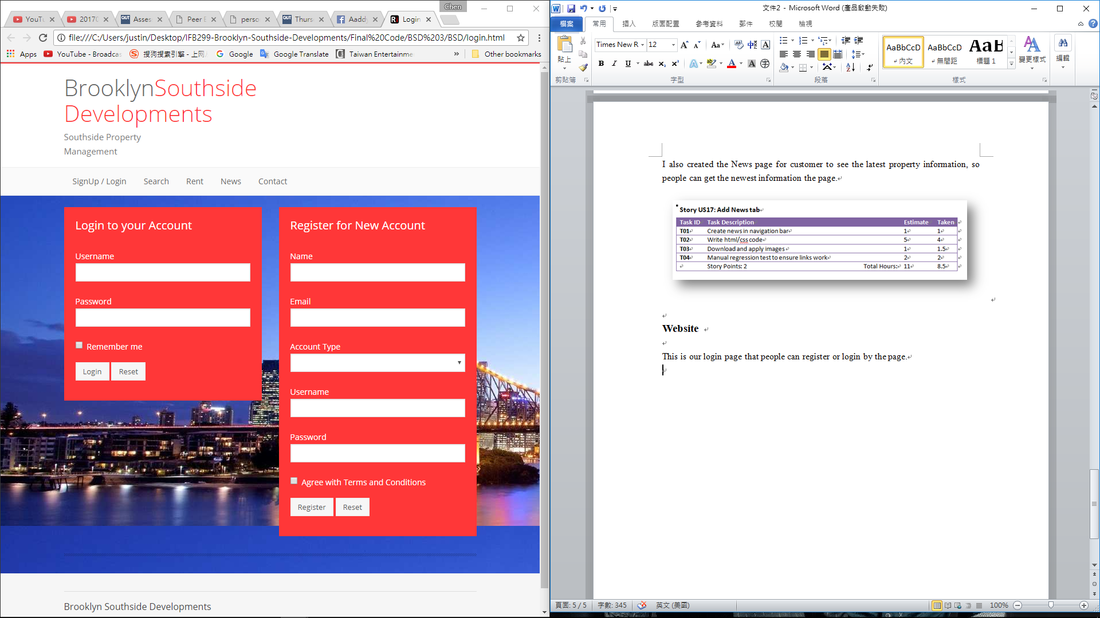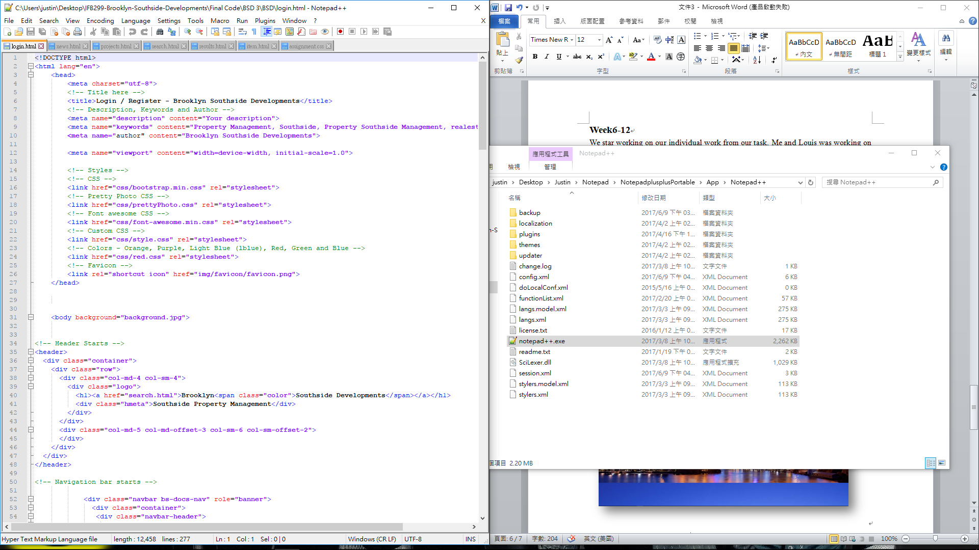

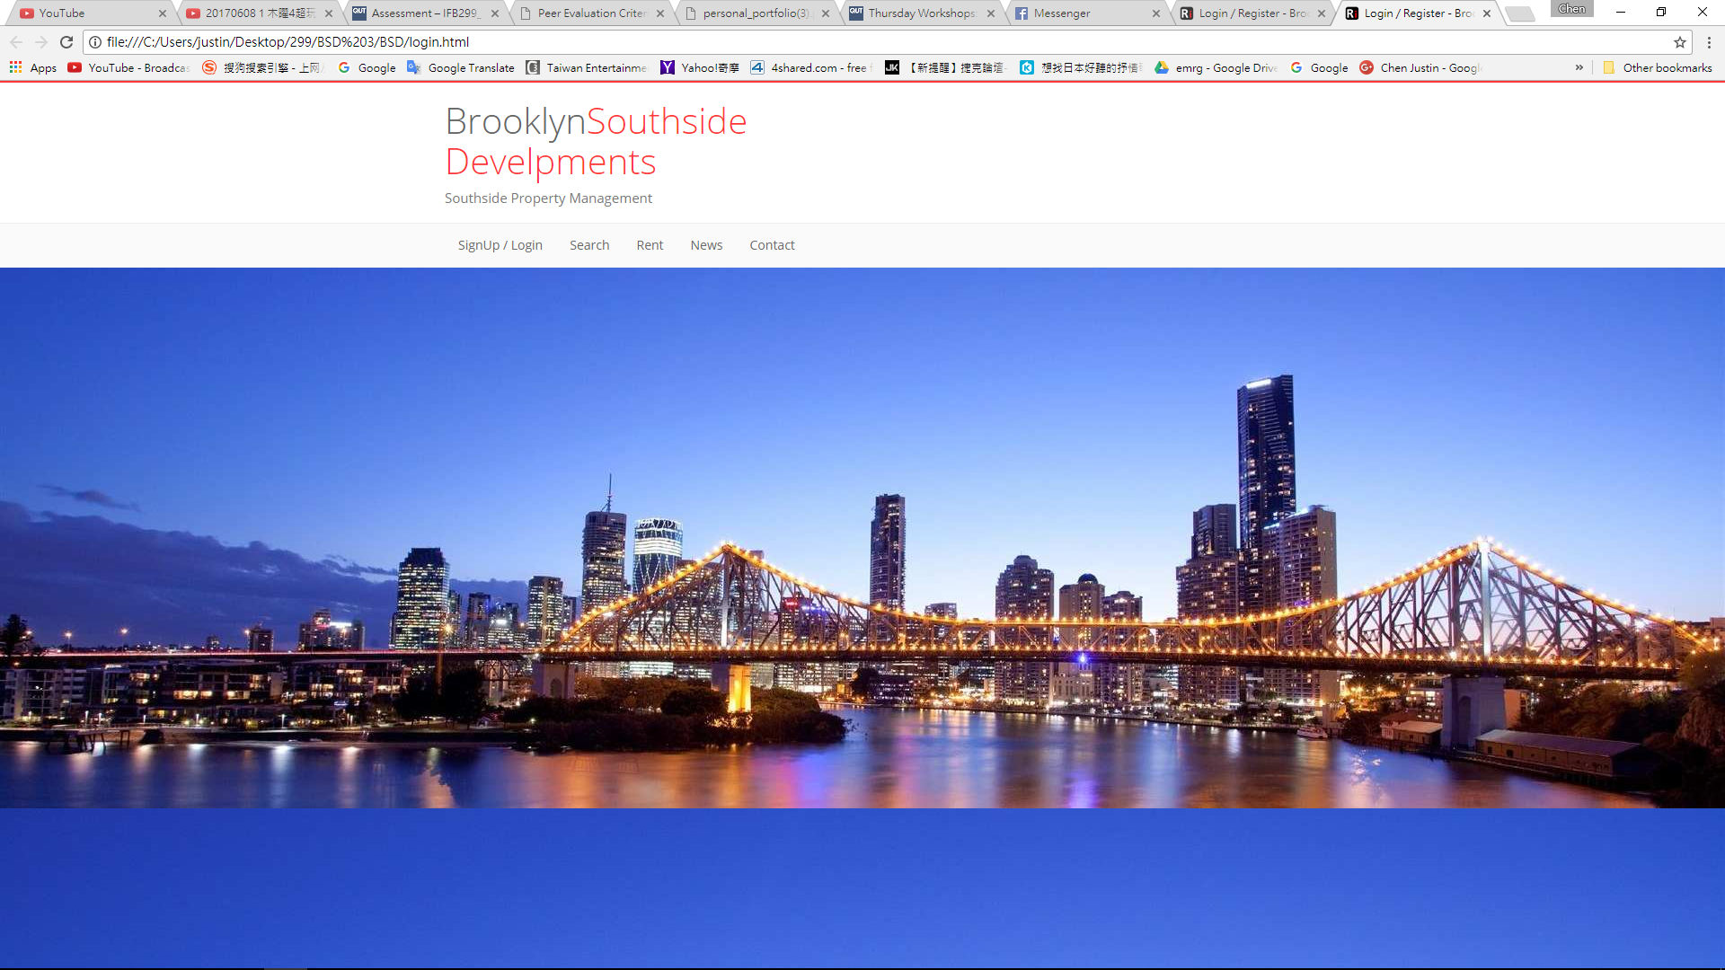

After we finish our sprint 1 task we continue working on our sprint 2 form to improve our web page looks more formal.

**Sprint Plan 2**

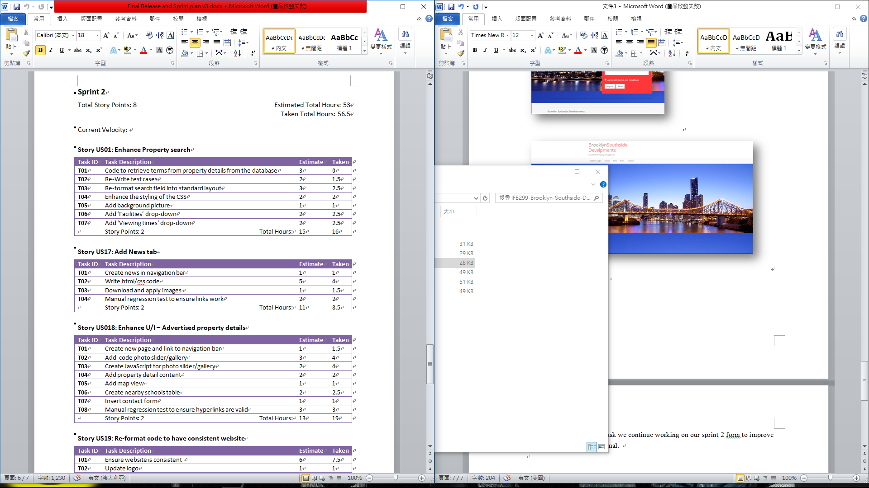

Then I keep writing the code for Login page, Result Page, Item Page, Search page, News Page, Contact Form, Background layout and CSS.

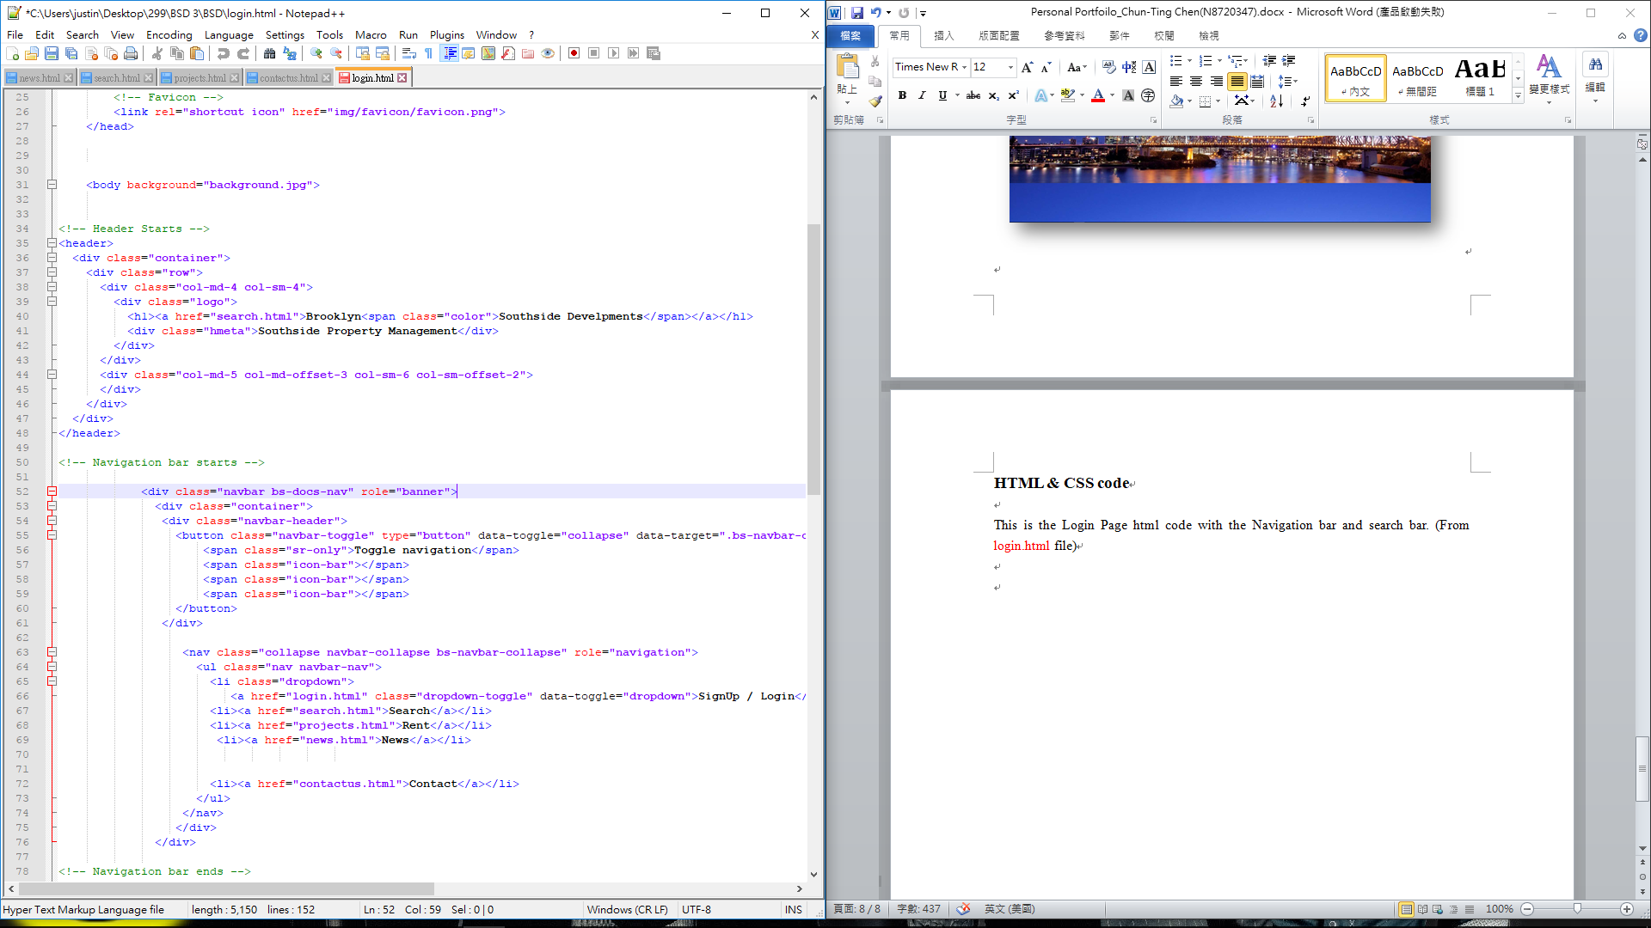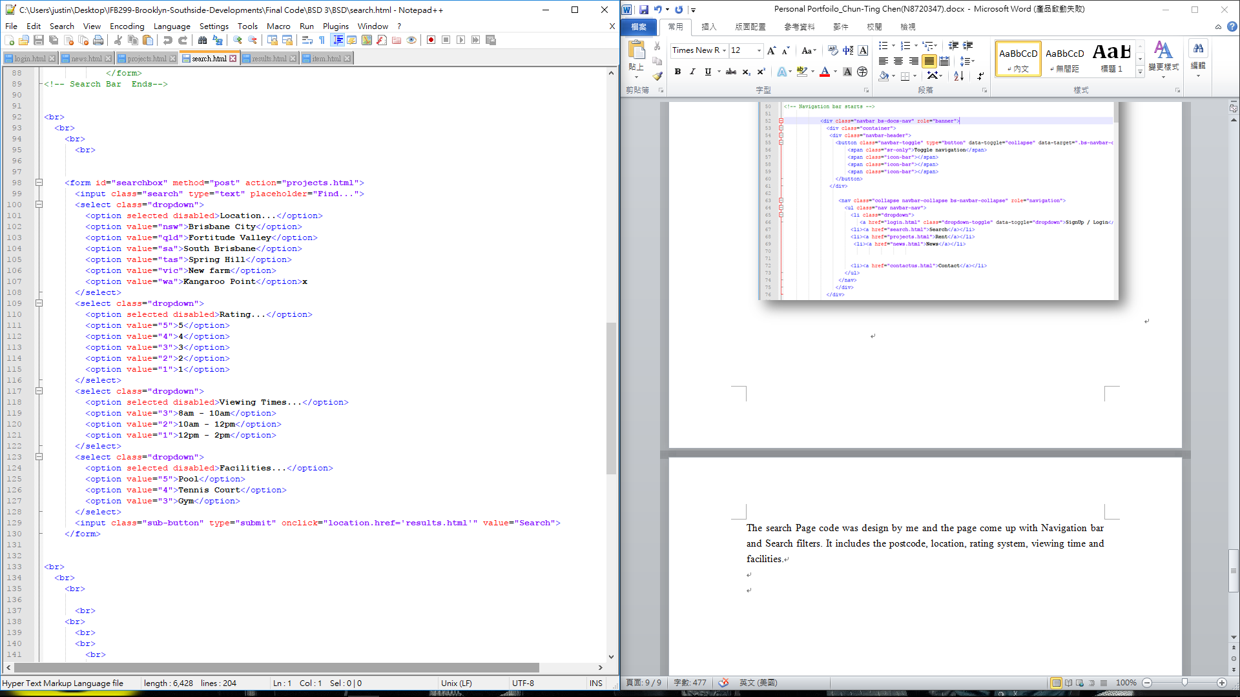

**Search Page**

**Login Page**

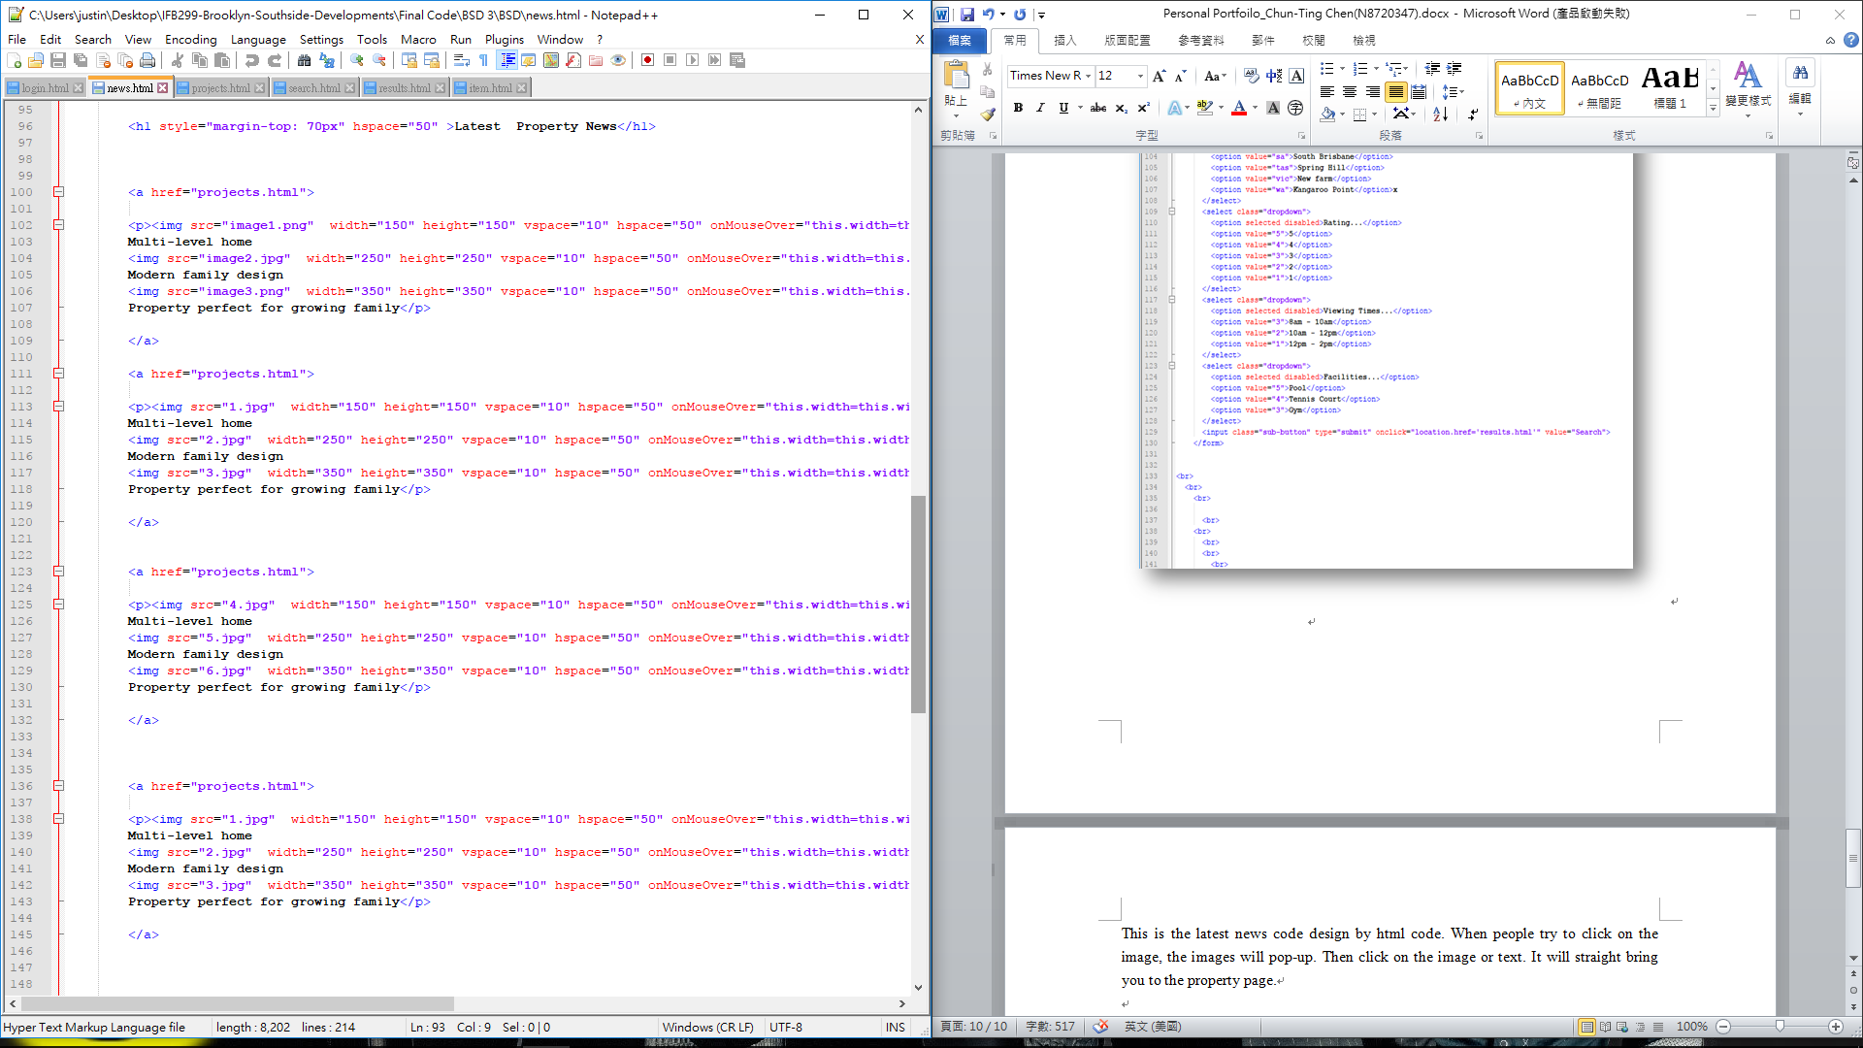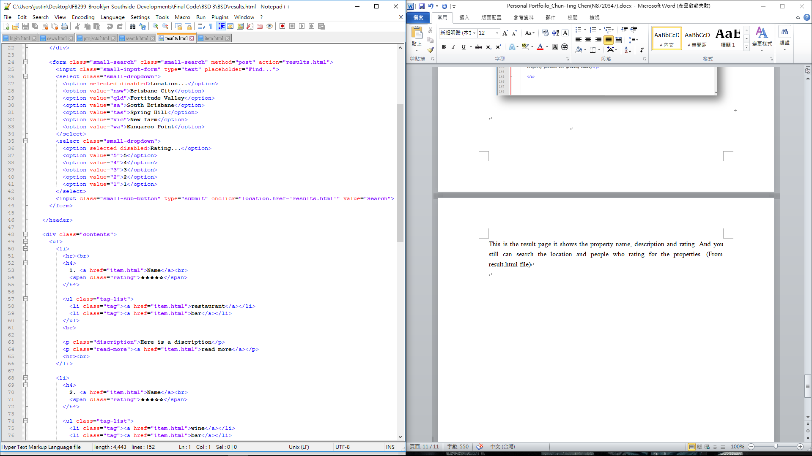

**Result Page**

**News Page**

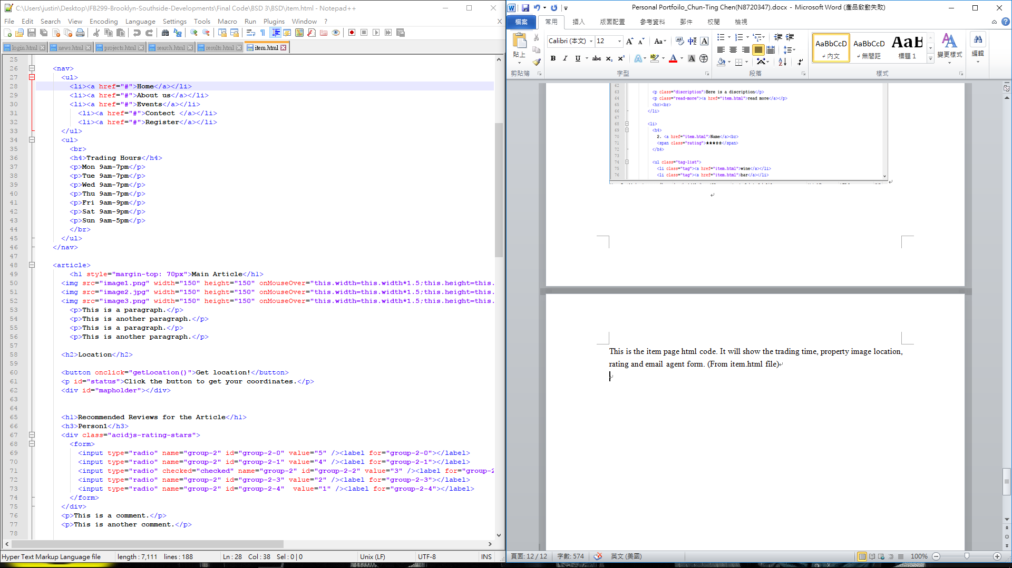

**Item Page**

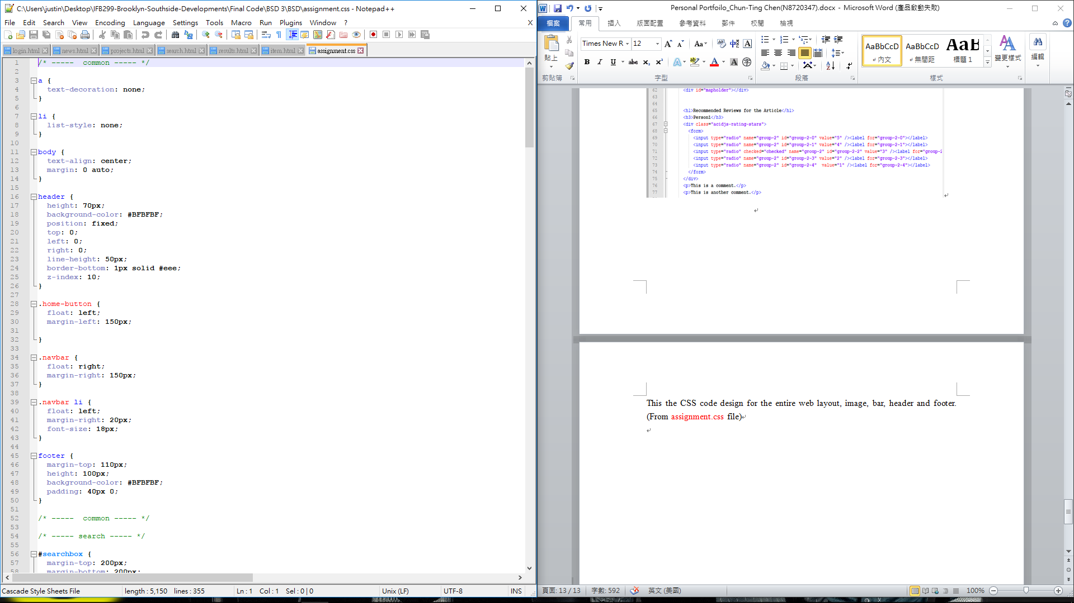

**CSS Code**

After I finish most of the code, I Start working on the test case form to make sure our website is working in right way. The test case will test step by step and double check the tasks are Pass or Fail from each section.

